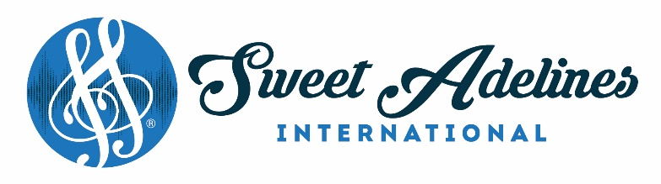

May 2021

M E M O

TO: CHARTERED CHAPTERS
ALL PROSPECTIVE CHAPTERS
REGIONAL FINANCE COORDINATORS

RE: VERIFICATION OF AUDIT – Fiscal Year (2020) Ending April 30, 2021
This form is due to International Headquarters by July 15, 2021.

VERIFICATION OF AUDIT

Each chapter and region is required to submit a verification of audit.

Each region’s or chapter’s financial records should be audited by an internal audit committee or an independent third party such as an accounting firm. When making arrangements for a third party to conduct the audit, be sure to discuss the fee. It is not necessary for the auditor to do a complete audit and issue a formal or unqualified opinion. The auditor should primarily seek to verify bank balances and the proper recording of receipts and disbursements.

Attached is the Verification of Audit form to complete. It may be returned via postal mail, fax or email at finance@sweetadelines.com. Please only send one copy. Form must be in PDF or Word Doc form.

If there are any questions regarding the verification of audit process, please contact the Finance Department, at finance@sweetadelines.com.

Please return to International Headquarters on or before July 15, 2021.

SWEET ADELINES INTERNATIONAL CORPORATION
9110 South Toledo Avenue
Tulsa, Oklahoma 74137
1.800.992.7464 1.918.622.1444 Fax: 1.918.665.0894

VERIFICATION OF AUDIT

Each chapter and region is required to submit a verification of audit annually.

The completion of this form is M A N D A T O R Y.

This is to verify that the chapter's or region's books and financial records for the period of May 1, 2020 to April 30, 2021 for tax year 2020, have been audited by an internal audit committee or an independent third party such as an accounting firm. When making arrangements for a third party to conduct the audit be sure to discuss the fee. It is not necessary for the auditor to do a complete audit and issue a formal or unqualified opinion. However, please provide any written opinions or statements issued by a third party. The auditor should primarily seek to verify bank balances and the proper recording of receipts and disbursements.

If receipt of delivery is desired, send via Certified Mail, Return Receipt Requested.

Indicate the type of audit conducted by the chapter below:
Internal Audit Committee
Accounting or bookkeeping firm*
Non-chapter member, non-accounting professional*
Non-chapter member, accounting professional*
Other*

Please provide Name, Contact Information, and Signature of Auditor:
NAME: _______________________________________________________________
ADDRESS: ____________________________________________________________
PHONE: ______________________________________________________________
EMAIL: _______________________________________________________________
SIGNATURE: __________________________________________________________

PLEASE COMPLETE THE FOLLOWING INFORMATION, AS APPLICABLE, FOR EITHER THE CHAPTER OR THE REGION.

CHAPTER NAME: REGION #: ___
REGION NAME: REGION #: ___

The financial records of the before mentioned chapter or region have been reviewed and/or audited to ensure that all transactions have been recorded properly and that no discrepancies have been identified.

SIGNATURE OF FINANCE COORDINATOR: ________________________________
DATE: ____________________________

***PLEASE COMPLETE THIS FORM AND RETURN TO INTERNATIONAL HEADQUARTERS IN PDF OR WORD DOCUMENT FORM, BY JULY 15, 2021.

