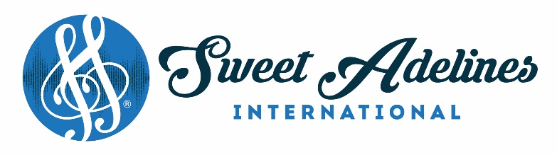

January 2025

M E M O

TO: CHARTERED CHAPTERS
ALL PROSPECTIVE CHAPTERS
REGIONAL FINANCE COORDINATORS

RE: VERIFICATION OF AUDIT – Fiscal Year (2025) Ending April 30, 2026
This form is due to International Headquarters by July 15, 2026.

VERIFICATION OF AUDIT

Each chapter and region is required to submit a verification of audit.

Each region’s or chapter’s financial records should be audited by an internal audit committee or an independent third party such as an accounting firm. When making arrangements for a third party to conduct the audit, be sure to discuss the fee. It is not necessary for the auditor to do a complete audit and issue a formal or unqualified opinion. The auditor should primarily seek to verify bank balances and the proper recording of receipts and disbursements.

Attached is the Verification of Audit form to complete.
Please use attached instructions to upload documents in your Chapter portal.

If there are any questions regarding the verification of audit process, please contact the Finance Department, at finance@sweetadelines.com.

Please upload forms to your Chapter Portal on or before July 15, 2026.
FORMS ARE NOT VALID UNLESS SIGNED & DATED BY FINACE OFFICER

For all US Chapters & Regions: This will be the same process for submitting, posting and uploading the IRS 990 return confirmations.

SWEET ADELINES INTERNATIONAL CORPORATION
9110 South Toledo Avenue
Tulsa, Oklahoma 74137
1.800.992.7464 1.918.622.1444 Fax: 1.918.665.0894

VERIFICATION OF AUDIT

Each chapter and region is required to submit a verification of audit annually.

The completion of this form is M A N D A T O R Y.

This is to verify that the chapter's or region's books and financial records for the period of _______ to _________ for tax year 2025, (this is normally May 1st to April 30th, unless your year end is December 31st) have been audited by an internal audit committee or an independent third party such as an accounting firm. When making arrangements for a third party to conduct the audit be sure to discuss the fee. It is not necessary for the auditor to do a complete audit and issue a formal or unqualified opinion. However, please provide any written opinions or statements issued by a third party. The auditor should primarily seek to verify bank balances and the proper recording of receipts and disbursements.

If receipt of delivery is desired, send via Certified Mail, Return Receipt Requested.

Indicate the type of audit conducted by the chapter below.

☐ Internal Audit Committee
☐ Accounting or bookkeeping firm *
☐ Non-chapter member, non-accounting professional *
☐ Non-chapter member, accounting professional *
☐ Other *

*Please provide Name, Contact Information, and Signature of Auditor:
Name:_________________________________________________________________________
Address:_______________________________________________________________________
Phone:_________________________________________________________________________
Email:__________________________________________________________________________
Signature:_______________________________________________________________________

PLEASE COMPLETE THE FOLLOWING INFORMATION, AS APPLICABLE, FOR EITHER THE CHAPTER OR THE REGION.

CHAPTER NAME Click or tap here to enter text. REGION #___
OR
REGION NAME Click or tap here to enter text. REGION #___

The financial records of the above-mentioned chapter or region have been reviewed and/or audited to ensure that all transactions have been recorded properly and that no discrepancies have been identified.

SIGNATURE OF FINANCE COORDINATOR ___________________________________
DATE____________________________

***PLEASE COMPLETE THIS FORM AND UPLOAD TO THE CHAPTER PORTAL UNDER THE DOCUMENT TAB BEFOE JULY 15, 2026.

Choose the account tab and Organization Info in your Chapter or Region portal
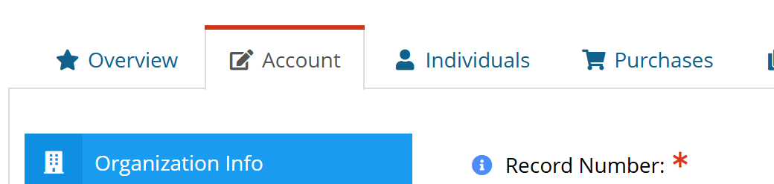

Scroll down to and check the mark for “Verification of Audit” and include “date of receipt” then click SAVE
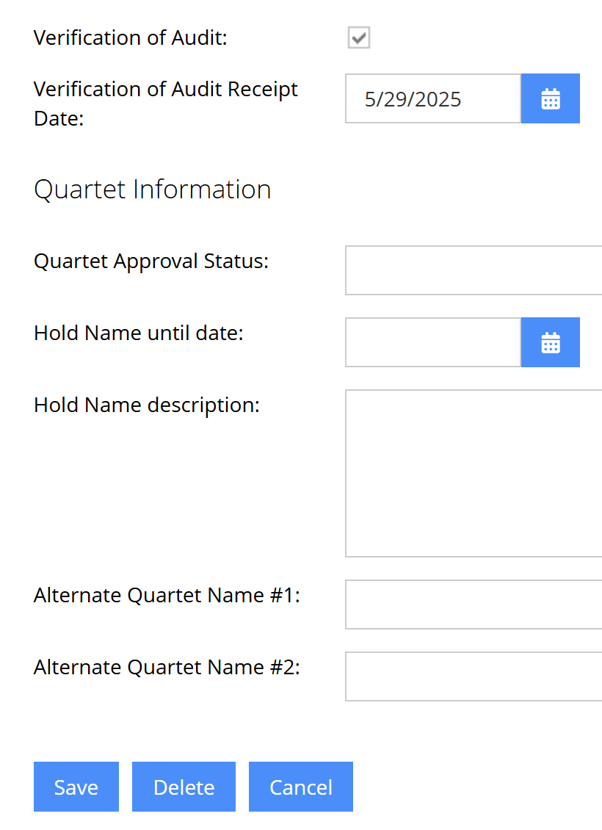

Go to DOCUMENT tab and click Upload……..
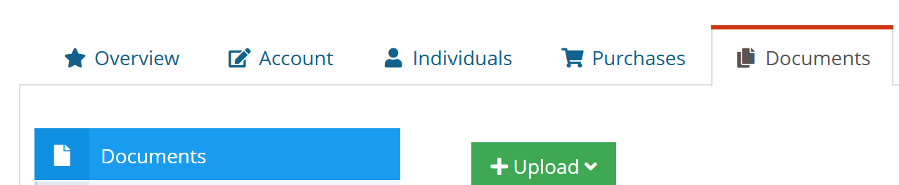

Click upload file
Click Browse
Choose your file document from your computer
Title should be (Audit year) and Form title, ie: 2025 VOA
Click Upload File
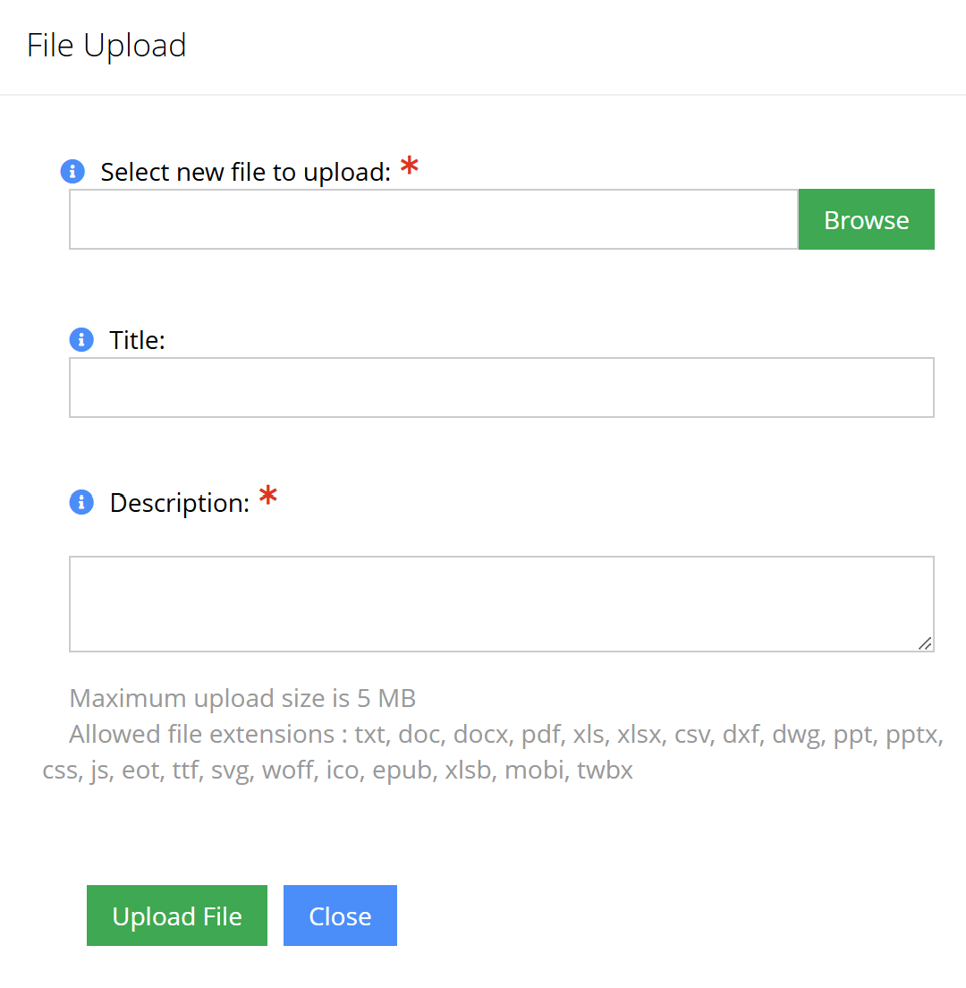
You should now see your file in your Chapter portal. Please click VIEW to ensure you have uploaded the correct document.
You will not receive an email receipt since you know you have put this in your portal. We will send you an email if we find something missing.

For all US Chapters & Regions: This will be the same process for submitting, posting and uploading the IRS 990 return confirmations.

