March & June 2026

M E M O

TO: United States, Chapter Finance Coordinators
United States, Regional Finance Coordinators
United States, All Prospective Chapters (who have obtained an EIN)

RE: Filing of United States Government Form 990 for 2025 (fiscal year ending April 30, 2026)

IMPORTANT INFORMATION

FAILURE TO FILE 990 INFORMATION FOR THREE CONSECUTIVE YEARS WILL RESULT IN AN AUTOMATIC REVOCATION OF THE CHAPTER OR REGION’S TAX-EXEMPT STATUS.

Although our organization’s year ends in 2026, this is considered a 2025 filing. The following information identifies which form your chapter or region must file.

EIN
Every chapter and region have their own EIN. If you need to verify the chapter or region EIN, please contact International Headquarters.

Forms to File:
Most tax-exempt organizations are required to file an annual return. Which form an organization must file generally depends on its financial activity, as indicated in the chart below. The IRS provides the following information at this link: https://www.irs.gov/charities-non-profits/form-990-series-which-forms-do-exempt-organizations-file-filing-phase-in
Status | Form to File | Instructions
Gross receipts normally ≤ $50,000  Note: Organizations eligible to file the e-Postcard may choose to file a full return | 990-N | n/a
Gross receipts < $200,000, and  Total assets < $500,000 | 990-EZ  or 990 | Instructions
Gross receipts ≥ $200,000, or  Total assets ≥ $500,000 | 990 | Instructions
Private foundation - regardless of financial status | 990-PF | Instructions

Additional information is available at the following IRS link:
https://www.irs.gov/charities-non-profits/annual-reporting-and-filing

FORM 990-N (e-postcard) Annual Electronic Filing Requirements
Chapters with $50,000 or less in gross receipts are only required to electronically file the Form 990-N (e- Postcard). For the fiscal year ending April 30, 2026, e-Postcards are due by September 15, 2026.

An E-Postcard must be filed on the IRS Web site. The information required for the electronic filing is as follows:

- Employer identification number (EIN)
- Tax year (2024)
- Legal name and mailing address of the chapter or region (name of chapter/region of Sweet Adelines International) P.O. Box address for the chapter/region is recommended to allow consistency.
- Name and address of a principal officer (finance coordinator/treasurer or president)
- Website address if chapter or region has one.
- Confirmation that the organization’s annual gross receipts are normally $50,000 or less.

To learn more about the 990N requirements and how to file: https://www.irs.gov/charities-non-profits/annual-electronic-filing-requirement-for-small-exempt-organizations-form-990-n-e-postcard

Even if the current year’s gross receipts were more than $50,000, the organization may be able to file a 990N if the following conditions apply:

An organization's gross receipts are considered to be $50,000 or less if the organization:

- It has been in existence up to one year and has received, or donors have pledged to give, $75,000 or less during the organization's first tax year;

- Has been in existence between one and three years and averaged $60,000 or less in gross receipts during each of its first two tax years; or

- Is at least three years old or more and averaged $50,000 or less in gross receipts for the immediately preceding three tax years (including the year for which the return would be filed).

990EZ and 990 FORMS

FORM 990EZ is required if gross receipts are less than $200,000 and total assets are less than $500,000 at the end of the year.

FORM 990 must be filed if a chapter or region has gross receipts greater than or equal to $200,000 or total assets greater than or equal to $500,000 at the end of the year.

Because of the complexity of the 990 Form, it is highly recommended that the 990EZ be filed if the gross receipts and assets requirement can be met.

To learn more about filing a Form, 990EZ or 990 please access the IRS website at:
https://www.irs.gov/charities-non-profits/current-form-990-series-forms-and-instructions

SCHEDULE A-Form 990 or 990-EZ

Schedule A should be used if filing Form 990 or Form 990-EZ. In Part I, Box 9 needs to be checked, part II does not need to be filled out, part III needs to be completed and part IV should be filled out only if needed.

SCHEDULE O-Form 990 or 990-EZ

Schedule O should be used to explain various line items on Form 990EZ or Form 990.

THE DEADLINE FOR FILING THESE FORMS WITH THE IRS IS SEPTEMBER 15 OF EACH YEAR.

PLEASE UPLOAD A PDF or WORD document COPY OF THE 990EZ OR 990 FILING TO YOUR CHAPTER PORTALALL FROMS MUST INCLUDE THE CHAPTER NAME AND EIN NUMBER.

Frequently Asked Questions

Q: How are gross receipts determined?
A: Gross receipts are all monies received from all sources, without deducting any costs or expenses, which contributed to the activities and operations of the organization. The exception to this is sales items. The net amount (gross sales less cost of goods) is reported in net receipts.

The following revenue is not reported as gross receipts.

a. The collection of International dues from members which are subsequently forwarded to Headquarters and regional assessments which are sent to the region. Any pass-through monies are not included. Pass through monies are defined as any funds collected as a convenience and forwarded to another entity.

b. Funds received for payment of registration or fees for future events that do not pertain to the current fiscal year.

EXAMPLE
The fiscal year ends April 30, 2026. Monies are received from members in March 2026 (or earlier in the year) for an event or workshop being held in June 2026. These funds may be recorded in an account titled "Deferred Income" and would not be reported as income for the fiscal year ending April 30, 2026.

On May 1, 2026, this amount would be transferred from the "Deferred Income” account on the balance sheet to an income account for the event or workshop and reported for the fiscal year ending April 30, 2027.

Q: If any of the Forms 990s must be filed, how can they be obtained?
A: Access the forms on the IRS Website at http://www.irs.gov, and click on Charities & Non-Profits. Click on Annual Reporting & Filing.

Q: How do I know if my state has filing requirements?
A: The finance coordinator should check with the appropriate state agency to see if there are any filing requirements. Sweet Adelines International's exemption from federal income tax does not necessarily exempt chapters or regions from filing requirements and tax requirements on the state and local level.

Each chapter and region is responsible for obtaining the necessary forms and for filing on a timely basis. This information should become part of the files and should be passed on to each finance coordinator.

Q: If assistance is needed to complete the Form 990s, who may be contacted?
A: Anthony Miller, at International Headquarters will answer any questions you may have regarding the requirements for filing or completing the forms, Anthony@sweetadelines.com or 1-800-992-7464 ext. 102.

Q: Where do I file the returns?
A: All 990 forms are sent to: Department of Treasury
The Internal Revenue Service Center
Ogden, Utah 84201-0027

AFTER FILING: PLEASE USE THE INSTRUCTIONS BELOW TO SUBMIT, POST AND UPLOAD YOUR FILING CONFIRMATION DOCUMENTS IN YOUR CHAPTER PORTAL

First, login to https://members.sweetadelines.com/

Upon login, select “Chapter Portal”

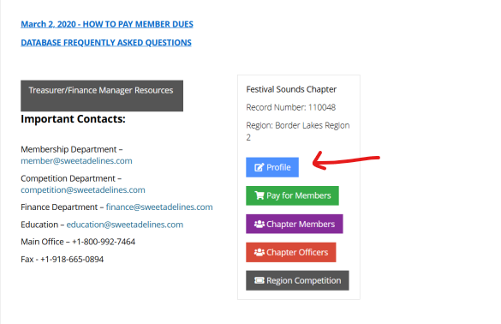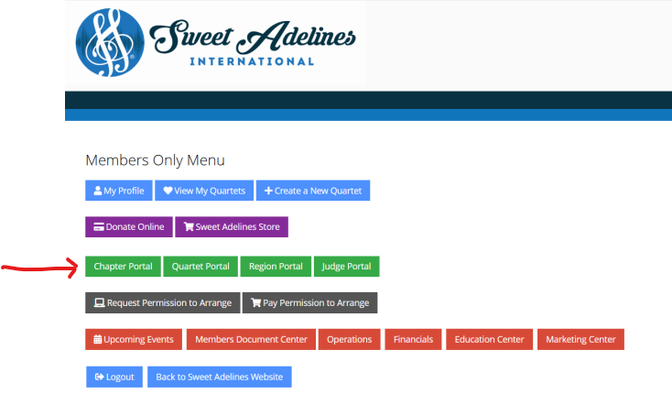

Choose the account tab and Organization Info in your Chapter or Region portal

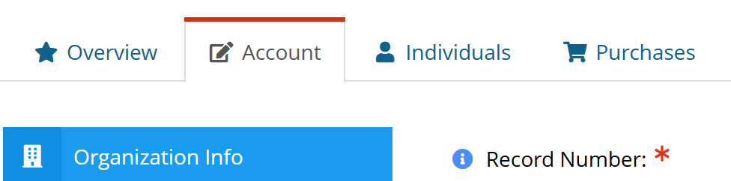

Scroll down to Financial Information and enter date and choose IRS form

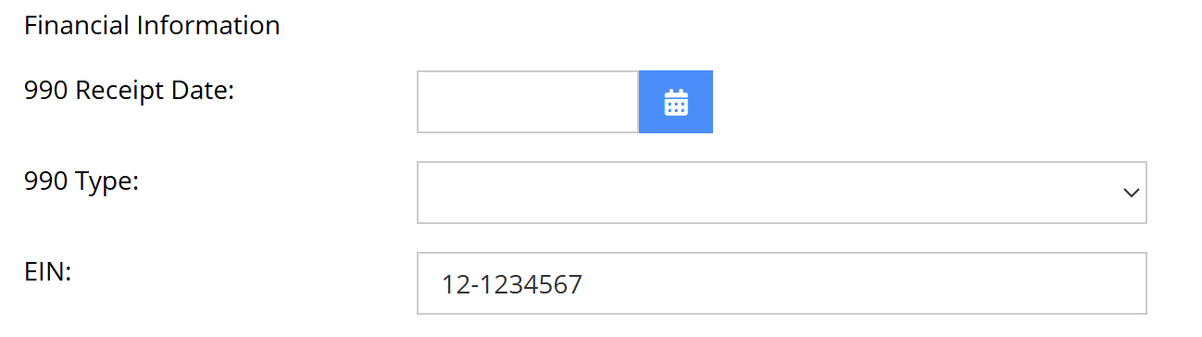



BE SURE YOU CLCK SAVE BEFORE LEAVING PAGE

Go to DOCUMENT tab and click Upload……..

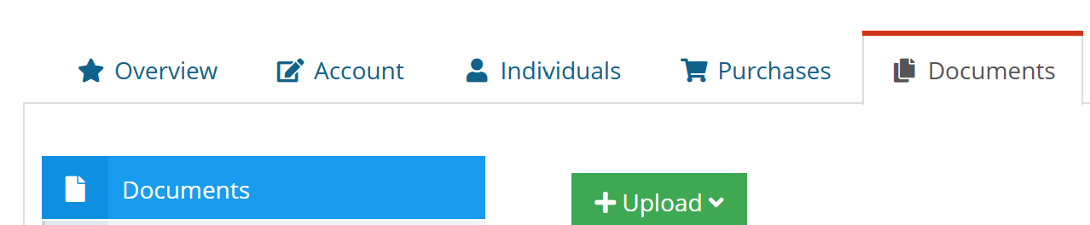

Click upload file
Click Browse
Choose your file document from your computer
Title should be year and Form title, i.e.: 2024 990, 990ez, 8869, etc...
Click Upload File
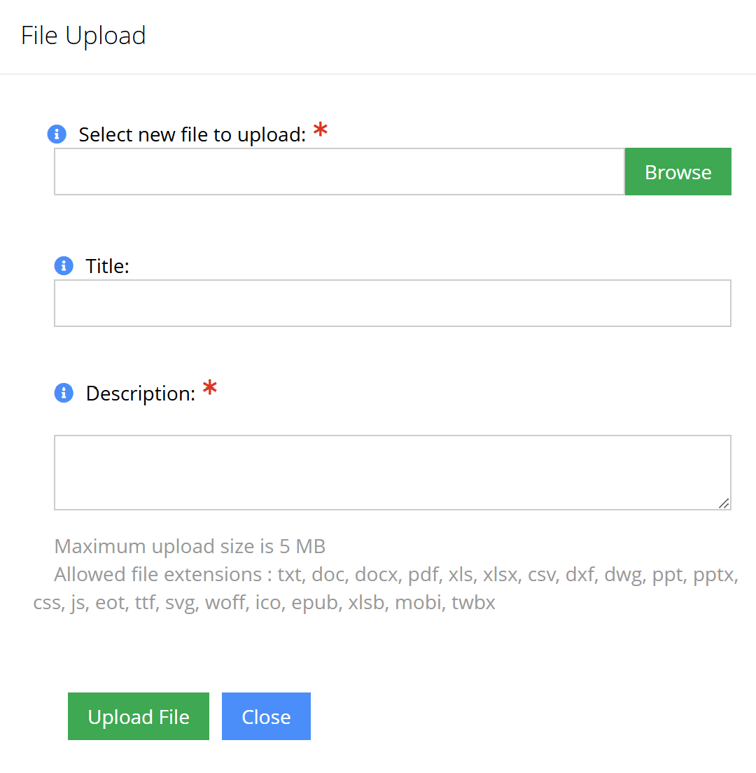

You should now see your file in your Chapter portal.

Please open your file and make sure you have chosen the correct file

