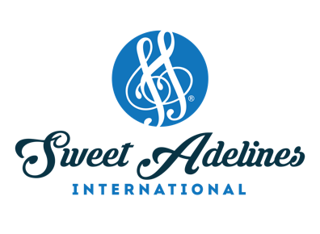
www.sweetadelines.com

Year Location Quartet Champion

1947 Tulsa Decaturettes

1948 Topeka Johnson Sisters

1949 St. Louis Tune Twisters

1950 Chicago Harmony Belles

1951 Santa Monica Quarternotes

1952 St. Petersburg Pitch Pipers

1953 Milwaukee Big Four

1954 Buffalo Mississippi Misses

1955 Grand Rapids Nota-Belles

1956 Wichita Junior Misses

1957 Miami Cracker Jills

1958 Peoria Sweet and Lows

1959 Tucson Yankee Misses

1960 Detroit Gibson Girls

1961 Colorado Springs Lyrics

1962 Toronto Sea-Adelines

1963 Berkeley Heathertones

1964 Minneapolis Note-Cracker Sweets

1965 Denver Shalimars

1966 Houston Piper-Ettes

1967 New York Hurricane Honeys

1968 Oklahoma City Galatones

1969 Honolulu Metropolitans

1970 Boston Rarities

1971 Kansas City Bron’s Tones

1972 Salt Lake City 4th Edition

1973 Washington, D.C. Tiffanys

1974 Milwaukee Sounds of Music

1975 Seattle Front Office Four

1976 Cincinnati High Society

1977 London, England Shondells

1978 Los Angeles Tetrachords

1979 St. Louis Hallmarks

1980 Atlanta Penna-Fores

1981 Phoenix All Star Jubilee

1982 Minneapolis Music Gallery

1983 Detroit Melo-Edge

1984 Las Vegas 4 For The Show

1985 Kansas City Jubilation

1986 Philadelphia Ambiance

1987 Hawaii Ginger ‘n Jazz

1988 Houston Savvy

1989 Miami Growing Girls

1990 Salt Lake City Panache

1991 San Antonio Swing Street

1992 Baltimore City Lights

1993* Indianapolis Showtime

1994 Reno Chicago Fire

1995 New Orleans Weekend Edition

1996 Ft. Lauderdale 4-Star Collection

1997 Salt Lake City Classic Edition

1998 Nashville Rumors

1999 Atlanta Signature Sound

2000 Orlando A Cappella Gold

2001 Portland Fanatix

2002 Nashville Swinglish Mix

2003 Phoenix Brava!

2004 Indianapolis the BUZZ

2005 Detroit SPOTLIGHT

2006 Las Vegas SALT

2007 Calgary Four Bettys

2008 Honolulu Moxie Ladies

2009 Nashville Zing!

2010 Seattle MAXX Factor

2011 Houston Martini

2012 Denver Touché

2013 Honolulu LoveNotes

2014 Baltimore Bling!

2015 Las Vegas Speed of Sound

2016 Las Vegas Frenzy

2017 Las Vegas Lustre

2018 St. Louis ClassRing

